Hot Standby Router Protocol Configuration

HOW TO CONFIGURE HSRP

Inacio Andre

2024

// TOPOLOGY //

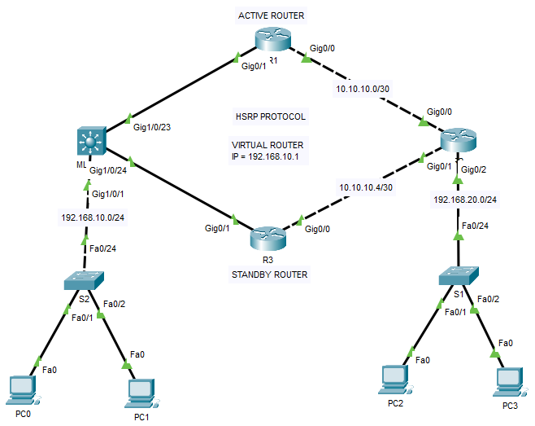

// BASIC CONFIGURATION //

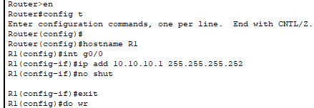

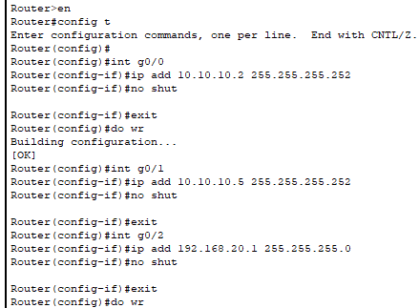

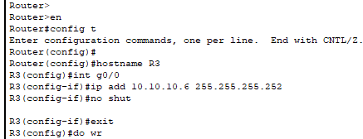

// OSPF ROUTING CONFIGURATION //

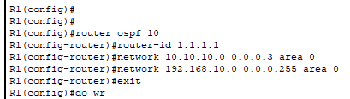

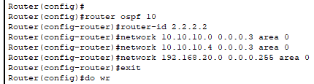

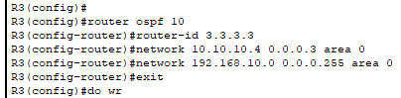

// HSRP CONFIGURATION //

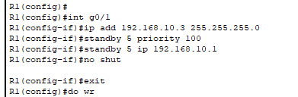

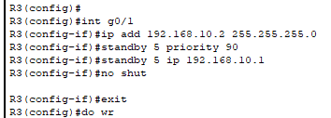

// TESTING HSRP CONFIGURATION //

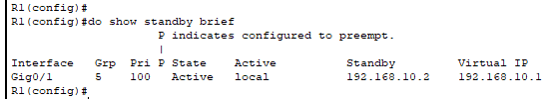

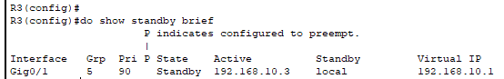

// TESTING COMMUNICATION //

PC0 T0 PC2 – PINGING

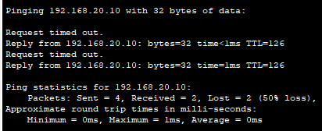

PC0 T0 PC2 – TRACEROUTE

